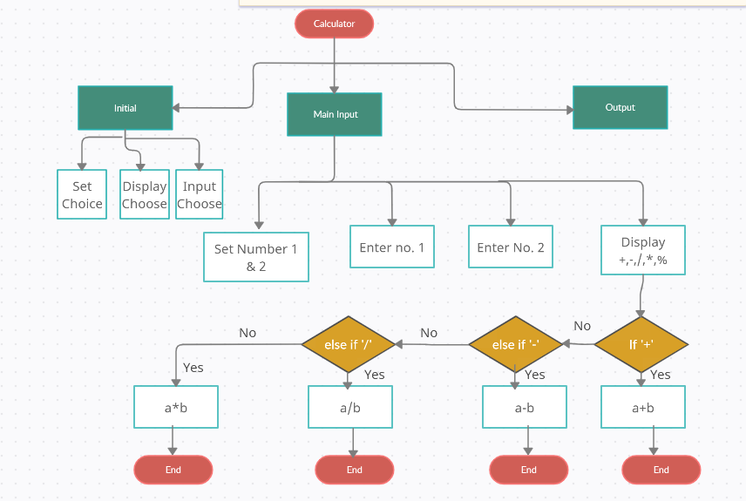

User Execute

Input

Correct input

Input is OK

Input is not OK

Display output